# CS 255 System Design Document Template

## UML Diagrams

### UML Use Case Diagram

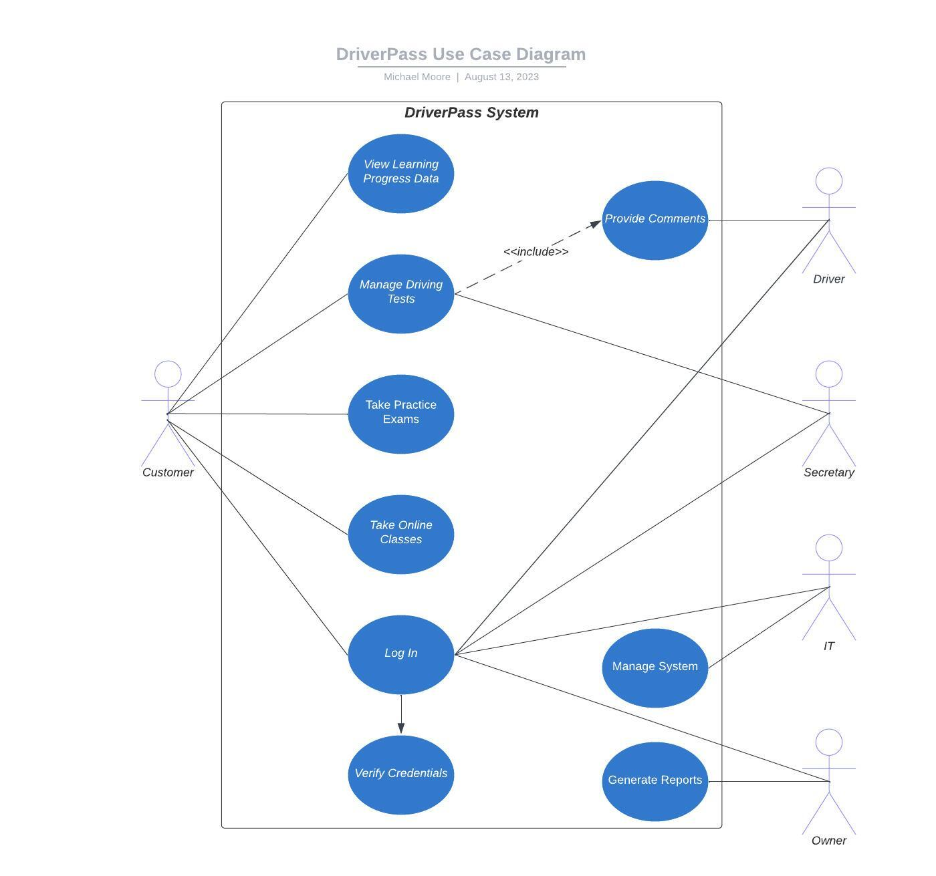

### UML Activity Diagrams

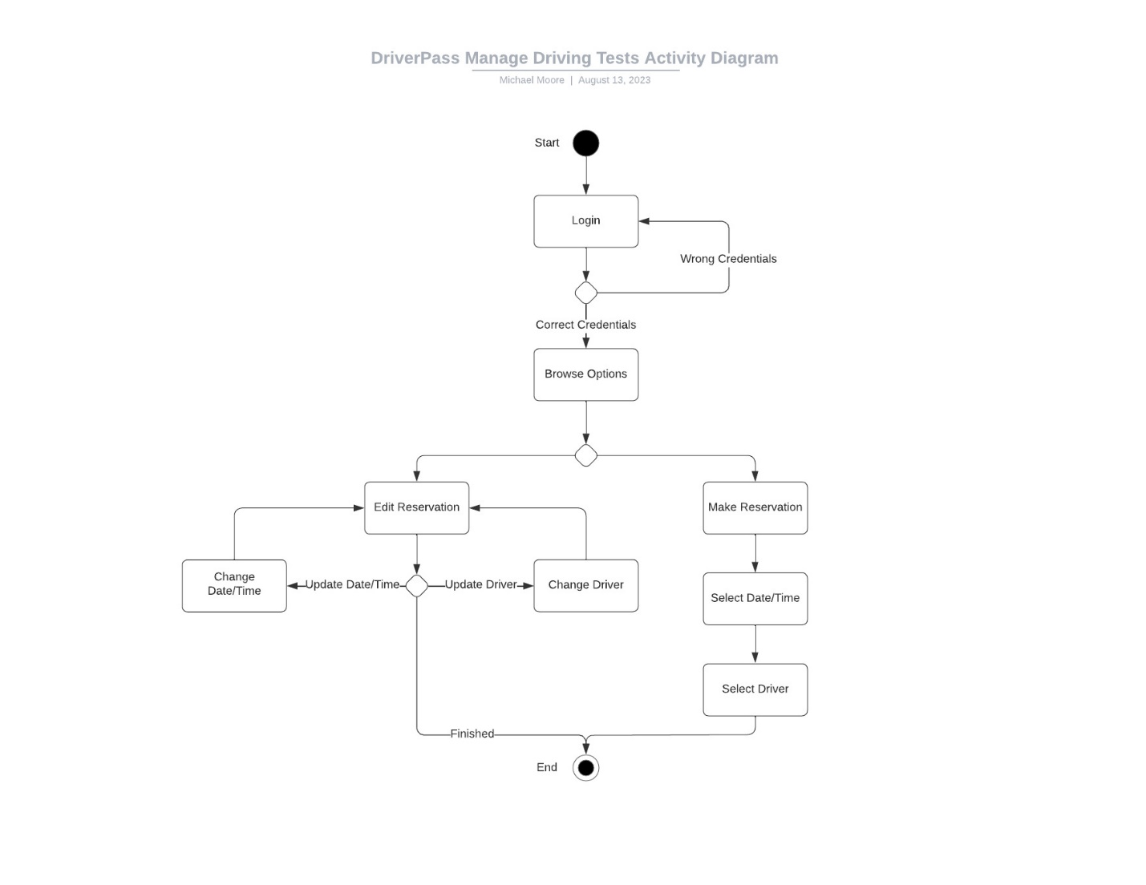

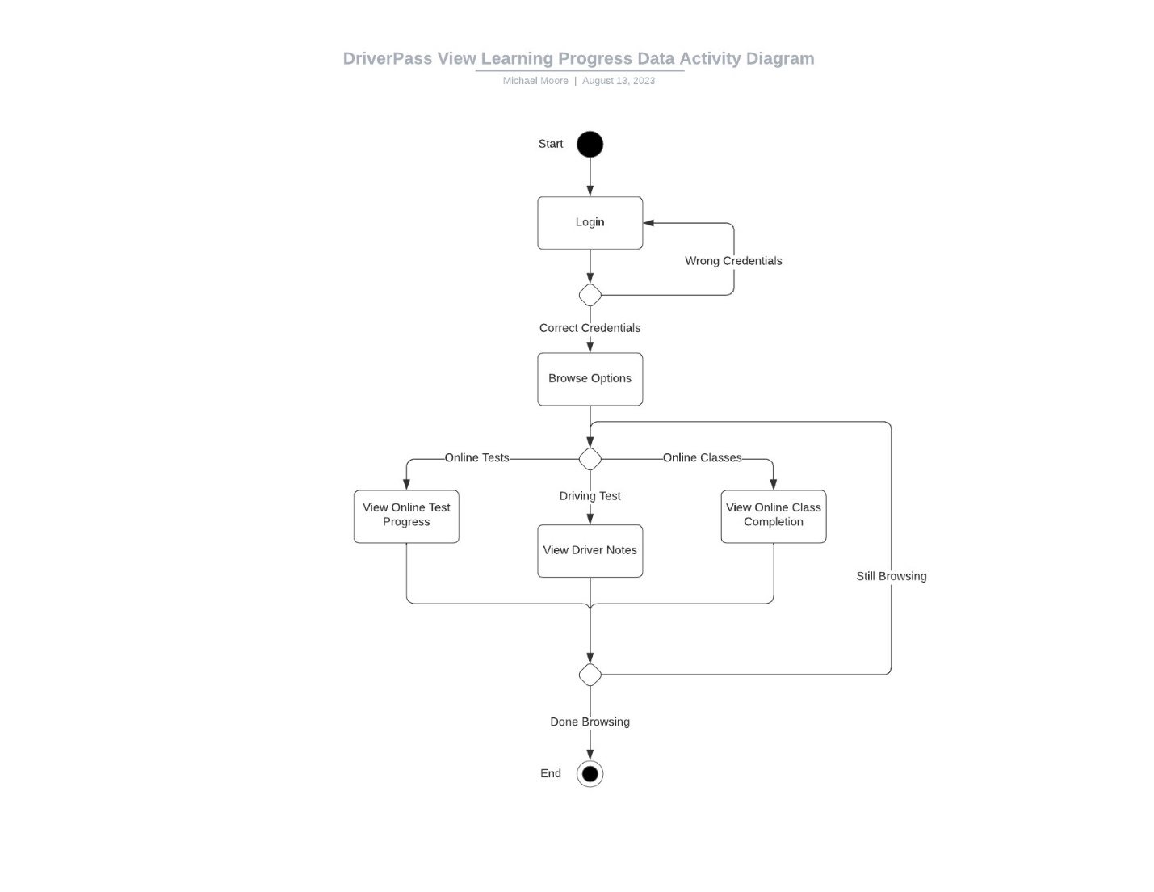

### UML Sequence Diagram

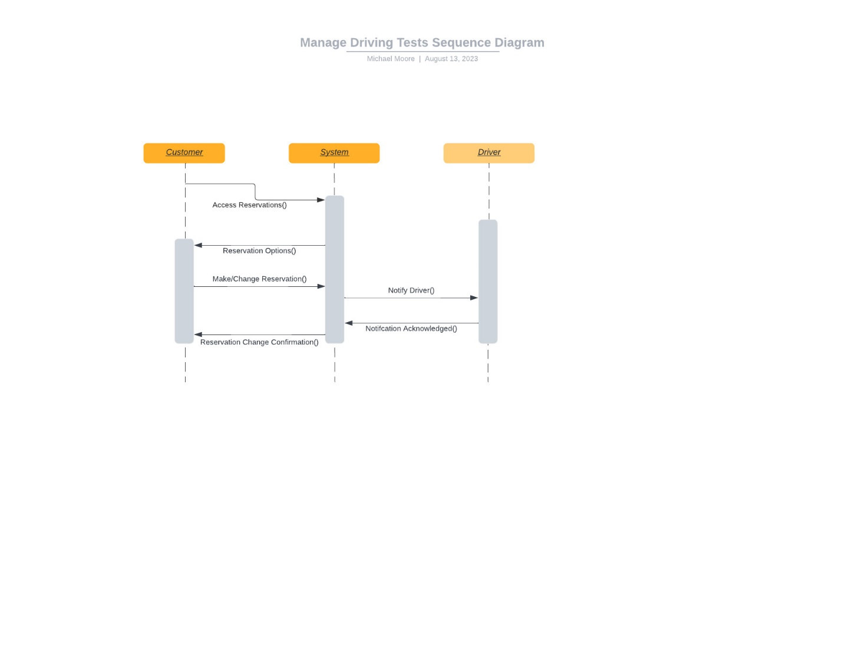

### UML Class Diagram

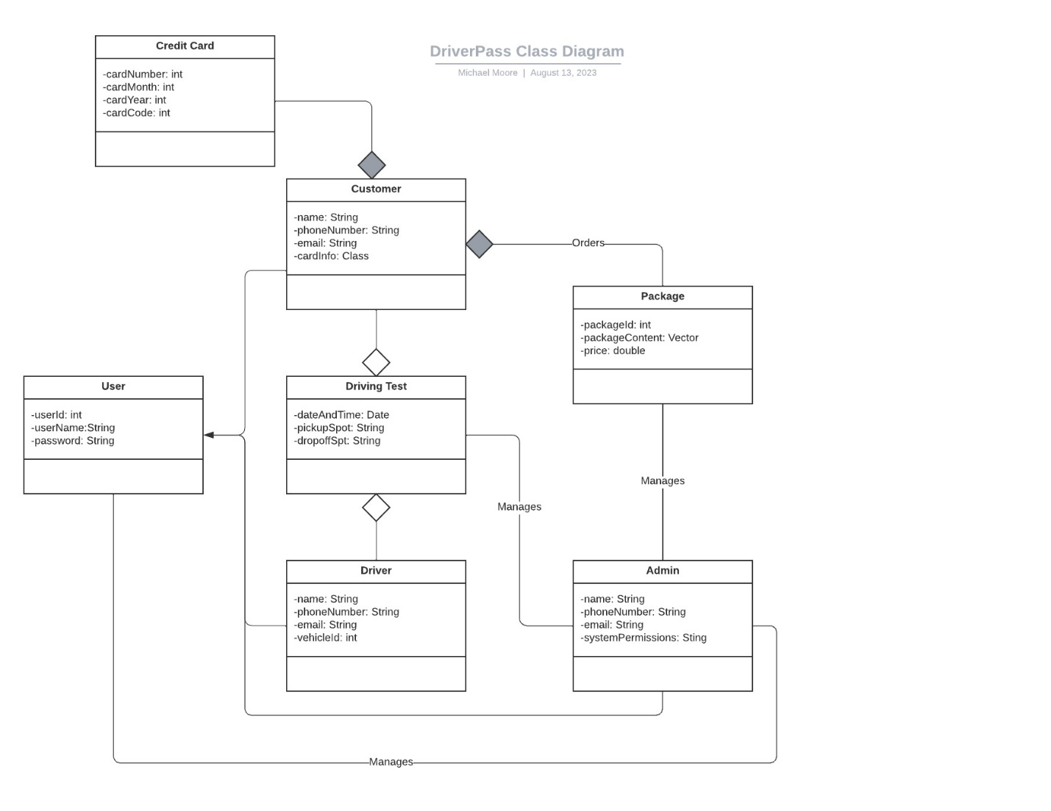

## Technical Requirements

**Hardware:**

DriverPass must have the following pieces of hardware to utilize the system:

* Computers, monitors, keyboards, and mice.
* Internet Service.
* Equipment to deliver the internet service across the DriverPass office.
* Computers must be compatible with Microsoft Azure.

**Software:**

DriverPass must have the following software capabilities:

* Computers must have Microsoft Azure Access for accessing the management side of the system.
* Computer must have any modern web browser for accessing the DriverPass system online.
* For later iterations of the system, programming development software may be desirable to implement new functionality.

**Tools:**

The only explicit tool required to manage this system is Microsoft Azure Access.

**Infrastructure:**

DriverPass requested the system to be hosted on a cloud service. This alleviates a lot of infrastructure setup as it is mostly managed by the cloud provider, Microsoft Azure.